Spinetoram

CIPAC 802

Small Scale Collaborative Trial

Small scale collaborative study for CIPAC method for Spinetoram TC and SC.

By

|  |  |
| --- | --- |
| Kevin King | Jennifer Jones |
| Clarke Mosquito Control | Corteva Agriscience |
| 675 Sidwell Court | 9330 Zionsville Rd |
| St. Charles, Illinois 60174 | Indianapolis, IN 46268 |

1. **Introduction**A small scale collaborative trial for CIPAC 802 Spinetoram was conducted to assess the performance of the analytical method for two Spinetoram formulation types: Technical (TC) and Suspension Concentrate (SC). Spinetoram is the sum of 2 separate molecules; Spinetoram-J (XDE-175-J) and Spinetoram-L (XDE-175-L).

This small scale trial, supported by ESPAC, utilized 7 different laboratories which analyzed two separate batches of each formulation type, these will be referenced as TC1, TC2, SC1, and SC2 throughout this report. Of the 7 laboratories that participated, one laboratory was found to be an outlier in the analysis of TC2 and SC2 while a straggler in the analysis of TC1 and SC1.   
The data provided was then analyzed to determine repeatability and reproducibility for each formulation type. To further support the robustness of the method, the Horwitz ratio was applied for each batch, and all of the ratios were found to be within the acceptable limit of > 0.3 and < 1.   
Based upon the consistency of the data generated, and the acceptable values found with the Horwitz equation, it is determined that the small scale collaborative trial has proven this methodology to be robust and adequate in performance for the analysis of TC and SC formulation types for Spinetoram. A proposal to proceed with a full scale collaborative trial on Spinetoram is to be made to CIPAC.

1. **Method Description**  
     
   **Spinetoram CIPAC 802 analytical method for TC and SC formulations**

**Outline of CIPAC Method**: Spinetoram is determined by reversed phase high performance liquid chromatography (HPLC) using UV detection at 250nm and external standardization.

**Reagents**

*Spinetoram* reference standard with known Spinetoram-J and Spinetoram-L purities

*Water* HPLC Grade

*Acetonitrile* HPLC Grade

*Methanol* HPLC Grade

*Buffer pH 5.5* 2g/L Ammonium Acetate in water

*Solvent Mix A*  Acetonitrile – Methanol 80 + 20 (v/v)

*Eluent* Solvent Mix A – Buffer pH 5.5 80 + 20 (v/v)[1]

*Calibration Solution* Weigh in duplicate (to the nearest 0.1mg) about 43mg of the Spinetoram standard (s mg) into separate volumetric flasks (100mL). Add water (about 10mL) and swirl briefly to disperse. Add methanol (50mL) and shake to dissolve. Adjust to mark with methanol and mix well (Solutions C1 and C2).

**Apparatus**

*High performance liquid chromatograph* equipped with an ultraviolet spectrophotometric detector and an injection system capable to inject 10µL

*Column* Phenomenex Luna C8(2) 3µ 150x4.6mm, or equivalent material with the same selectivity

*Electronic Integrator*

*Mechanical Shaker*

*Disposable filters*, solvent compatible, porosity 0.45µm Nylon

**Procedure**

* 1. *Chromatographic Conditions (typical)***Table 1. Chromatographic conditions**

|  |  |
| --- | --- |
| **Parameter** | **Specification** |
| Column Temperature | 30 ºC |
| Flow Rate | 1.0 mL/min |
| Measuring Wavelength | 250 nm |
| Injection Volume | 10 µL |
| Run Time | Approx. 20min |
| Retention Time | Spinetoram-J: 10- 12min  Spinetoram-L: 12-15min |

* 1. *Equilibration of the system*  
     Pump sufficient eluent through the column to equilibrate the system. Inject 10µL portions of the calibration solution C1 and repeat the injections until retention times and peak areas vary by less than ±0.5% of the mean for three successive injections.
  2. *Sample preparation (TC)*Weigh (to the nearest 0.1mg) approximately 50mg Spinetoram TC (*w* mg) into a volumetric flask (100mL). Add water (10mL) with a volumetric pipette and swirl to disperse. Add methanol (50mL) and shake until completely dissolved. Dilute to mark with methanol and mix well. Sample not required to be filtered. (Solution S)
  3. *Sample Preparation (SC)*Weigh (to the nearest 0.1mg) approximately 360mg Spinetoram SC (*w* mg) into a volumetric flask (100mL). Add water (10mL) with a volumetric pipette and swirl to disperse. Add methanol (50mL) and shake for at least 5 minutes on a mechanical shaker. Adjust solution to volume with methanol and filter through a 0.45µ nylon filter, discarding the first 2-3mL of filtrate. (Solution S)
  4. *Determination*Inject 10µL portions of the calibration solutions (C1 and C2) and of the sample solutions (S1, S2, …, etc.) in the following sequence:  
     C1,S1,C2, S2, …

Determine the peak area of each Spinetoram component (Spinetoram-J and Spinetoram-L) and calculate the response factors (*f*) from the calibration solutions bracketing the injections of the sample solutions. Average the response factors of the calibration solutions preceding and following the sample solution injections. The results for each individual component **must** be calculated separately and then added together for the total Spinetoram content. Do not add the areas together first.

* 1. *Calculations  
       
     Amount Spinetoram-J or Spinetoram-L (mg) = Wa × P*Where*:  
     Wa = weight of respective component in calibration solution  
     P = Purity, decimal*  
       
     RF = Amount Spinetoram* ÷ Area Spinetoram*  
       
     Where:  
     *RF* = Response factor for respective component J or L  
     *Amount Spinetoram\** = calculated amount of respective J or L component (mg) in calibration solution  
     *Area Spinetoram\** = Peak area for respective J or L component in calibration solution  
       
     Weight % = Area Spinetoram* × RF ÷ S × 100%  
       
     Where:  
     *Weight %* = Weight % of respective J or L component  
     *Area Spinetoram\** = Peak area of respective J or L component in sample solution  
     *RF =* Response factor calculated for respective J or L component  
     *S = Sample weight, mg*  
     The total amount of Spinetoram is the sum of the weight % of Spinetoram-J and Spinetoram-L.

1. **Method Assessment**  
   According to the CIPAC guidelines for collaborative study procedures for assessment of performance of analytical methods, CIPAC 802 Spinetoram was investigated.  
   Two formulation types, TC and SC, were utilized in the study. Each formulation type had two separate batches investigated for a total of four separate samples. Each batch was prepared in duplicate each of two separate days, for a total of 8 data points per batch. A total of 7 labs participated in this study. 8 sets of data were generated as one laboratory performed the study using the specified column as well as a second time using an equivalent column.  
     
   The nominal concentration of the technical material is 858g/kg and the nominal concentration of the suspension concentration is 117g/kg  
   The following laboratories participated in the small scale collaborative trial:

**Table 2. Participating Laboratories**

|  |
| --- |
| **Laboratory** |
| The Pesticide Control Laboratory Backweston, Cellbridge W23 X3PH Co. Kildare, Ireland |
| Walloon Agricultural Research Centre Carson Building Rue du Bordia, 11 B-5030 Gembloux, Belgium |
| National Food Chain Safety Office Food Chain Safety Laboratory Directorate Pesticide Analytical National Reference Laboratory, Velence H2481 Velence, Orszag ut 23. Hungary |
| Bayer – Crop Science Bayer Agriculture bvba Haven 627 Scheldelaan 460 B-2040 Antwerpen Belgium |
| Clarke Mosquito Control Inc 675 Sidwell Court St. Charles, Illinois 60174 USA |
| Corteva Agriscience – Indianapolis USA 9330 Zionsville Rd Indianpolis, Indiana 46268 |
| Central Institute for Supervising and Testing in Agriculture (CISTA) National Reference Laboratory Department of Testing Plant Protection Products Zemedelska 1a 613 00 BRNO  Czech Republic |

* 1. **Individual Laboratory Results**Each laboratory generated 8 results per formulation per batch. Lab 7 performed an extra set of data on a second HPLC column (freshly prepared standards and samples), so for all intents and purposes to compare the data generated on that column compared to the other labs and equipment, it was treated as a separate set of data. One HPLC column utilized was the column specified in the method, and the second set of results was generated with a separate “equivalent” column. Part of the objective of the small scale trial was to verify that columns outside of the specified column can generate reproducible data.

**Table 3. TC-1 Laboratory data**



**Table 4. TC-2 Laboratory Data**



**Table 5. SC-1 Laboratory Data**  


**Table 6. SC-2 Laboratory Data**



All statistical analysis was performed using the average values for each lab.

* 1. **Determine any outliers**  
     The Grubbs’ Test was utilized to determine whether any of the data points was considered a straggler or an outlier. The critical values used were for *p* = 8. This put the upper 1% value at 2.274 and the upper 5% value at 2.216. Both the largest and smallest value was tested, utilizing the average results for each lab for each respective formulation type and batch.

**Table 7. Average laboratory value for each formulation batch**

|  |  |  |  |  |
| --- | --- | --- | --- | --- |
| **Lab** | **TC1 Average (g/kg)** | **TC2 Average (g/kg)** | **SC1 Average (g/kg)** | **SC2 Average (g/kg)** |
| 1 | 902.72 | 905.40 | 120.83 | 126.76 |
| 2 | 908.28 | 914.36 | 121.04 | 126.60 |
| 3 | 875.54 | 873.91 | 117.24 | 118.14 |
| 4 | 903.87 | 912.78 | 120.98 | 126.19 |
| 5 | 899.02 | 904.38 | 121.83 | 127.12 |
| 6 | 916.69 | 918.89 | 119.89 | 127.29 |
| 7-1 | 914.45 | 918.00 | 121.63 | 127.21 |
| 7-2 | 900.02 | 908.02 | 120.74 | 125.23 |

The minimum and maximum values for each data set were the following:

**Table 8. Minimum and maximum values for each formulation batch**

|  |  |  |  |  |
| --- | --- | --- | --- | --- |
|  | **Min Value** | | **Max Value** | |
| **Formulation** | Value (g/kg) | Lab | Value (g/kg) | Lab |
| TC1 | 875.54 | 3 | 916.69 | 6 |
| TC2 | 873.91 | 3 | 918.89 | 6 |
| SC1 | 117.24 | 3 | 121.83 | 5 |
| SC2 | 118.14 | 3 | 127.29 | 6 |

It was observed that the lowest values for each test material came from the same laboratory, laboratory 3. All of these values, the minimum and maximum, were tested against the critical values using the equations listed in ISO 5725-2 1994, section 7.3.4.1.

**Table 9. Results from Grubbs Statistical analysis**

|  |  |  |  |  |
| --- | --- | --- | --- | --- |
| Upper 1% | 2.274 |  | Upper 5% | 2.126 |
|  | TC1 | TC2 | SC1 | SC2 |
| Lowest Value | 875.54 | 873.91 | 117.24 | 118.14 |
| Grubbs Statistic – lower value | 2.133* | 2.293** | 2.262* | 2.706** |
|  |  |  |  |  |
| Highest value | 916.69 | 918.89 | 121.83 | 127.29 |
| Grubbs Statistic – higher value | 1.114 | 0.827 | 0.902 | 0.561 |

*Straggler  
**Outlier  
  
Grubbs statistic values were compared to the upper 1% and 5% values. If the Grubbs statistic was < 5% critical value, the result in question was accepted. If the statistic was > 5% critical value and < 1% critical value, then the result in question was considered a straggler. If the statistic was > 1% critical value, the result in question was considered an outlier.   
  
Based upon this analysis, every minimum result was classified as either an outlier or a straggler while every maximum value of the data set was accepted. One commonality between all of the minimum values is that they all came from the same laboratory. All of the chromatograms and submitted data was examined to look for any deviations, or signs that the methodology may have been performed incorrectly but there was no evidence to support this. The only significant observation is the laboratory utilized a C18 column in lieu of a C8 column as specified in the method.  
  
Without any way to be confident enough to exclude laboratory 3 completely, statistical analysis was performed with stragglers included and outliers removed.

* 1. **Determine the Repeatability**Repeatability was determined using the average results for each lab for each batch of material. Analysis was performed per ISO 5725-2 1994 section 7.4.5.1. Based on the results from the Grubbs’ test, Lab 3 for TC2 and SC2 was not included in the statistical analysis as these values were considered outliers. Repeatability was determined as repeatability variance * 2.8.

**Table 10. Repeatability Data**

|  |  |  |  |  |
| --- | --- | --- | --- | --- |
| **Sample** | **TC1** | **TC2** | **SC1** | **SC2** |
| **Repeatability Standard Deviation (g/kg)** | 4.69 | 5.64 | 0.73 | 0.68 |
| **Repeatability (g/kg)** | 13.14 | 15.78 | 2.05 | 1.90 |

* 1. **Determine the Reproducibility**  
       
     Reproducibility was determined using the average result for each lab for each batch of material. Analysis was performed per ISO 5725-2 1994 section 7.4.5.2. Based off the results from the Grubbs’ test, Lab 3 for TC2 and SC2 was not included in the statistical analysis as these values were considered outliers. Reproducibility was determined as reproducibility variance * 2.8.

**Table 11. Reproducibility Data**

|  |  |  |  |  |
| --- | --- | --- | --- | --- |
| **Sample** | **TC1** | **TC2** | **SC1** | **SC2** |
| **Reproducibility Standard Deviation (g/kg)** | 13.42 | 7.89 | 1.60 | 0.97 |
| **Reproducibility (g/kg)** | 37.56 | 22.08 | 4.49 | 2.71 |

* 1. **Application of the Horwitz Equation**  
     The Horwitz equation is defined as follows:  
       
     %RSD = 2(1-0.5*log(C))  
       
     C = concentration of analyte expressed as a decimal.  
       
     The ratio between the %RSD of the results and the %RSD from the Horwitz equation provides a value known as the Horwitz ratio. This ratio can be indicative of the repeatability of a method and whether the results can be seen as acceptable or not.  
     The following criteria is generally accepted as the interpretation of the Horwitz Ratio.

**Table 12. Horwitz Ratio Criteria**

|  |  |
| --- | --- |
| **Horwitz Ratio Range** | **Acceptability** |
| 0.3 < Ratio < 1 | Acceptable |
| Ratio < 0.3 or 1 < Ratio < 2 | Acceptable but may require explanation |
| Ratio > 2 | Not acceptable |

Applying this criteria we can determine that all four samples had acceptable ratios. For TC2 and SC2, as with the previous statistical analyses, Lab 3 was excluded as it was considered an outlier.

**Table 13. Horwitz Ratio Analysis**

|  |  |  |  |  |
| --- | --- | --- | --- | --- |
| **Sample** | **TC1** | **TC2** | **SC1** | **SC2** |
| %RSD | 1.40 | 0.64 | 1.20 | 0.58 |
| %RSD Horwitz equation | 1.44 | 1.43 | 1.94 | 1.93 |
| Horwitz Ratio | 1.0 | 0.4 | 0.6 | 0.3 |

Using the Horwitz ratio, the data generated supports the robustness of this method for both TC and SC formulations.

1. **Participant Comments and Deviations from Proposed Method**The following is a summary of any comments made by the participating labs, as well as highlighting any deviations or differences from the proposed methodology.

**Table 14. Summary of comments and deviations**

|  |  |  |
| --- | --- | --- |
| **Lab** | **Comments** | **Deviations** |
| 1 | None | None |
| 2 | Suggests that the calibration stock solution should have the water added after the dissolution of the active ingredient and that they sonicated to completely dissolve active ingredient. Technical sample preparation has the same suggestion and they suggest sonication added to the preparation of the SC as well. | None |
| 3 | None | Column: Purospher RP-18e 125x4mm 5µ Flow Rate: 1.2mL/min |
| 4 | Retention times were shorter than proposed in method. | Column: Luna C8(2) 100x4.6mm 3µ |
| 5 | Retention times were shorter than proposed in method. | None |
| 6 | Retention times were shorter than proposed in method. | Column Temperature: 25ºC |
| 7 | Suggestion to not use water in preparation of Standard and Technical samples, utilize ultrasonic bath opposed to mechanical shaking, and to mix the mobile phase offline and filter through 0.22µ filter. | Data set 1: None Data set 2: Column: Zorbax Eclipse XDB-C8 150x4.6mm 3.5µ |

All of the suggestions that were proposed would not impact the integrity of the method if they were implemented, they mostly focus on the preparation of the samples and the methodology behind dissolution of the active ingredient or formulation. Sonicating or shaking mechanically should yield equivalent results so long as the active ingredient is completely dissolved. Regarding the comment for filtering the mobile phase – this is believed to be common analytical practice but may be addressed by adding a comment in the method to remind the analyst to filter mobile phase prior to utilization on the HPLC.  
  
There were also several deviations that were noted. Most deviations were related to the column utilized in the analysis. Every column that was used in this study was a variation of a C8 column with the exception of laboratory 3 which used a C18 column. Based on the statistical analysis, and that laboratory 3 produced data that was either an outlier or straggler for every batch, it is recommended that a C18 column is not used for this methodology as a substitute. Seeing as this laboratory not only changed from a C8 to a C18 column but also changed the flow rate, the full impact of these individual deviations cannot be assessed.  
  
There were also multiple labs that reported a shorter retention time. For one of these labs, laboratory 4, the column length was reduced from 150mm to 100mm without a decrease to flow rate. This justifies the shorter observed retention time.  
The retention times for laboratory 4 and 5 were found to be about 7-8 minutes for Spinetoram-J and 9-9.5 minutes for Spinetoram-L while the method shows their retention times to be 10-12 minutes and 12-15 minutes, respectively. While these observed retention times are much shorter, the data generated by both of these laboratories was consistent with the data generated by all of the other laboratories. This suggests that the reduced retention time is not significant and could be attributed to many factors such as the instrument dead volume, whether the column was a 3 or 5µ column, or other factors such as small variations in the pH of the mobile phase.

1. **Conclusion**This small scale collaborative trial for Spinetoram was completed by 7 separate laboratories, analyzing two separate batches of TC and two separate batches of SC, over two days. The average result from each laboratory for each batch of formulation was utilized in statistical analysis to determine the repeatability, reproducibility as well as determine the Horwitz ratio to aid in determining method acceptability.  
   The initial assessment of the data showed that Laboratory 3 was inconsistent, compared to the other 6 laboratories, with their results. Based upon the Grubbs’ test for outliers, Laboratory 3 was a straggler in two batches (TC1 and SC1) as well as an outlier in the other two batches (TC2, and SC2). The biggest difference between laboratory 3 and the other laboratories was that laboratory 3 utilized a C18 column in the analysis opposed to a C8 column. This deviation may or may not be the cause of the inconsistent data, and no exact reasoning could be found, so the laboratory was not excluded completely from the data analysis. Where their result was found to be a straggler, laboratory 3 was included in the repeatability, reproducibility and determination of the Horwitz ratio. The method may be updated to specify only a C8 column may be used.  
   The repeatability for the TC and SC formulations was determined to be, respectively, 14.46g/kg and 1.97g/kg. The reproducibility for the TC and SC formulation was determined to be, respectively, 29.82g/kg and 3.60g/kg.  
   The Horwitz ratio was used to assist in the acceptability of the methodology. The ratios for TC1, TC2, SC1, and SC2 were 1.0, 0.4, 0.6, and 0.3, respectively. All of these values fell between the “acceptable” range of > 0.3 and < 1.0, suggesting that this method is in fact robust and provides acceptable performance for Spinetoram TC and SC formulations.  
   There were a few comments suggested to make the preparation of standards and samples easier, such as using an ultrasonic bath opposed to a mechanical shaker to dissolve, as well as omitting the water in the preparation of the standard and TC formulation. The method may be updated to reflect the application of these comments but it was determined that they would not have a significant impact on the integrity of the method and may be integrated for the ease of the analyst in performing the method.  
   Overall, it was deemed the small scale trial was successful and produced consistent, repeatable and reproducible results.   
   The English Speaking PAC (ESPAC) proposes to CIPAC that a full scale collaborative study for Spinetoram technical and formulations, based on the method reported here, can move forward.

**Appendix I – Collaborative Study Presentation of Results**

|  |  |  |  |  |
| --- | --- | --- | --- | --- |
| **Statistical variable** | **TC1** | **TC2** | **SC1** | **SC2** |
| X | 902.57 | 911.69 | 120.52 | 126.63 |
| L | 7 | 7 | 7 | 7 |
| Sr | 4.69 | 5.64 | 0.73 | 0.68 |
| SL | 12.57 | 5.52 | 1.43 | 0.69 |
| SR | 13.42 | 7.89 | 1.60 | 0.97 |
| RSDr | 0.52 | 0.62 | 0.61 | 0.54 |
| RSDR | 1.49 | 0.86 | 1.33 | 0.76 |
| r | 13.14 | 15.78 | 2.05 | 1.90 |
| R | 37.56 | 22.08 | 4.49 | 2.71 |
| RSDR(Hor) | 1.44 | 1.43 | 1.94 | 1.93 |

Where:

X = average  
L = number of laboratories  
Sr = repeatability standard deviation  
SL = “pure” between laboratory standard deviation  
SR = reproducibility standard deviation  
RSDr = repeatability relative standard deviation  
RSDR = reproducibility relative standard deviation  
r = repeatability  
R = reproducibility  
RSDR(Hor) = Horwitz value

**Appendix II – TC1 Statistical Bar Chart**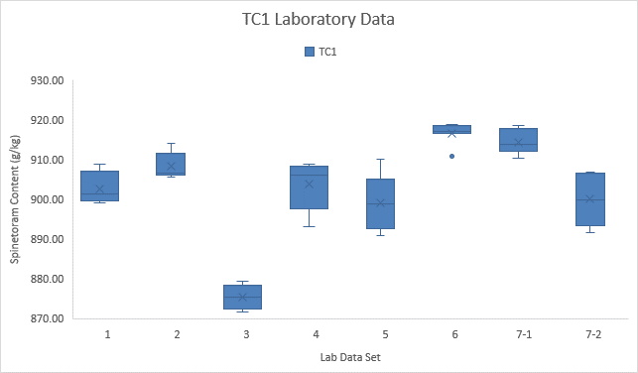

**Appendix III – TC2 Statistical Bar Chart**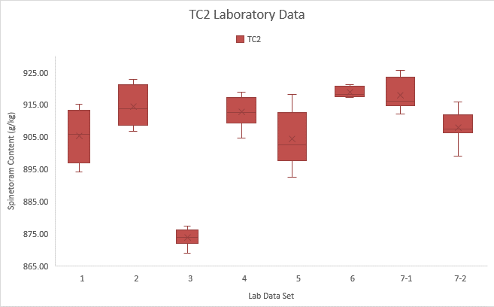

**Appendix IV – SC1 Statistical Bar Chart**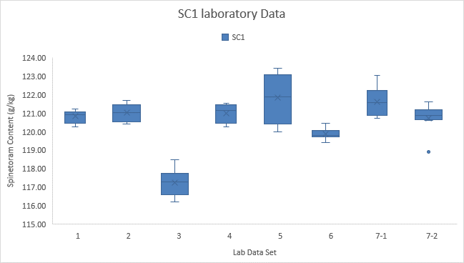

**Appendix V – SC2 Statistical Bar Chart**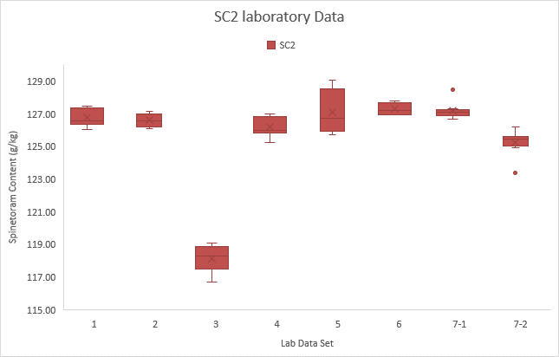

1. If mixed online this ratio is equivalent to Acetonitrile – Methanol – Buffer 64 + 16 + 20 (v/v/v)